INTER_VLAN ROUTING BASICS

Q1. In Cisco Packet Tracer, create three VLANs named Foodies, Shoppers, and Streamers to represent users of Zomato, Flipkart, and Spotify, and assign at least one PC to each VLAN.
Ans. I have created 3 VLAN and assigned one pc on each VLAN
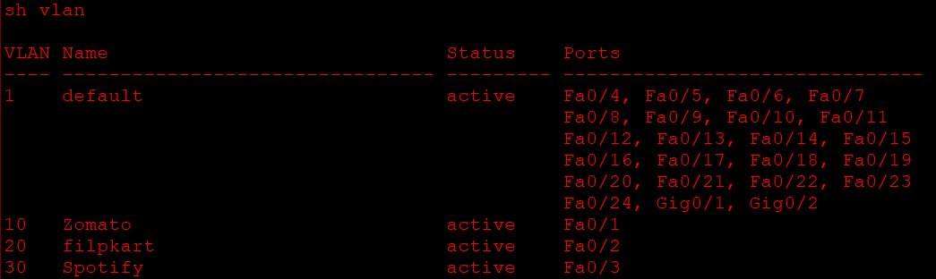
Q2. Configure a router-on-a-stick setup in Packet Tracer so that PCs in the Foodies, Shoppers, and Streamers VLANs can all ping each other using sub-interfaces on the router (e.g., GigabitEthernet0/0.10, .20, .30).
Ans. I have configured Sub-interfaces for the Different VLANS on the router.
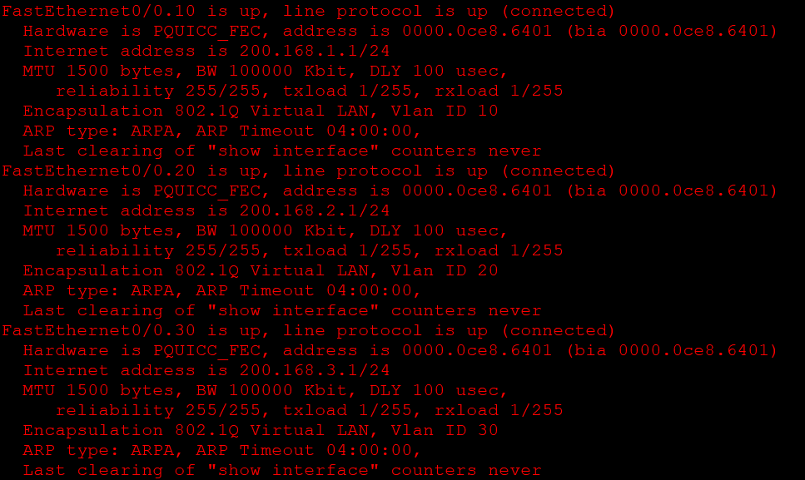
Q3. Assign IP addresses to each PC in your VLANs and set their default gateways to the corresponding router sub-interface IPs to enable inter-VLAN communication.
Ans. I have assigned IP’s to all pc with their default gateways to corresponding router sub-interface IP’s
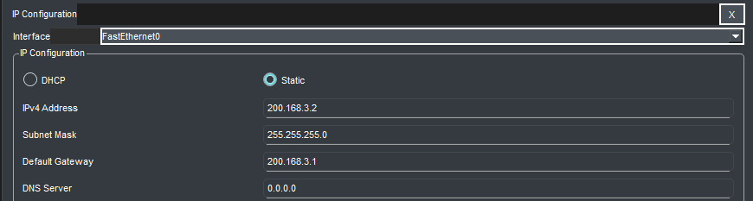
Q4. Simulate a scenario where users in the Shoppers VLAN (Flipkart) cannot ping users in the Streamers VLAN (Spotify). Identify and fix the misconfiguration causing the issue, then verify connectivity. Hint: Check VLAN assignments, router sub-interface configurations, and trunk port settings.
Ans. I have used ping command to ping Flipkart’s VLAN pc with the pc of Spotify VLAN and it gets failed and then I have use the switchport mode trunk command. After using this command the pc is now successfully communicating with the pc on different VLAN
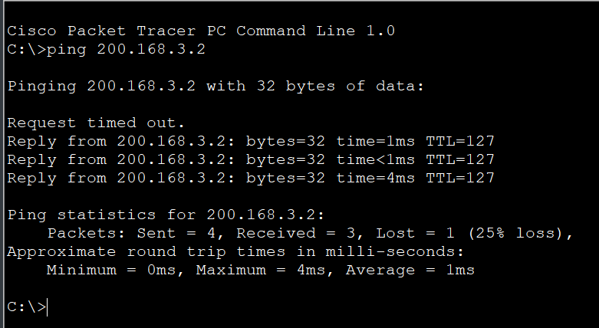
Q5. Compare the router-on-a-stick method you just configured with inter-VLAN routing using a Layer 3 switch: list two advantages and two disadvantages of each approach in a table.
Ans. Objective: To compare the advantages and disadvantages of Router-on-a-Stick and Layer 3 Switch methods for inter-VLAN routing.
Method | Advantages | Disadvantages
Router-on-a-Stick | 1. Cost-effective because it uses a single router interface for multiple VLANs. | 1. Slower performance because all inter-VLAN traffic passes through one physical link.
 | 2. Easy to configure and suitable for small networks. | 2. The trunk link can become a bottleneck during heavy traffic.
Layer 3 Switch | 1. Provides faster inter-VLAN routing using hardware-based switching. | 1. More expensive than a basic Layer 2 switch.
 | 2. Handles multiple VLANs efficiently without requiring an external router. | 2. Configuration and management can be more complex.

